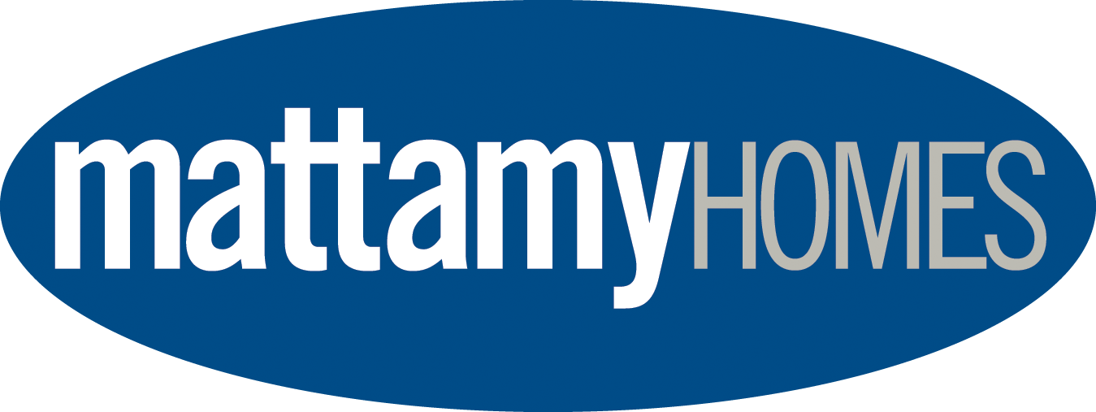


42nd ANNIVERSARY MATTAMY HOMES
CANADA DAY IN BARRHAVEN
July 1, 2024, 11a.m. – 11p.m., Clarke Fields

I hope this letter finds you well. I am reaching out to you on behalf of our 100% volunteer organization to request your support as a sponsor for this year's Canada Day in Barrhaven celebration. For 42 years, our partnership of community volunteers, associations, service clubs and businesses have banded together to put on the region’s largest local Canada Day celebration.

By becoming a sponsor, your business will have the opportunity to demonstrate its commitment to our community and gain valuable exposure to up to 35000+ area residents and visitors.

The multi day event features:
- Kids Zone with free activities, crafts and entertainment
- Multicultural Day featuring song and dance performances.
- County & Classic Music Day
- Parade of flags, Opening ceremonies and singing of the National Anthem
- 6 days of Midway rides and games
- Live entertainment on the Main Stage with a sound and light show guaranteed to please
- Fireworks choreographed to music
Check out our on-line schedule for dates for the different activities

Want to see it in action? Visit https://www.canadadaybarrhaven.ca to see a video of our 2023 celebration.

We are committed to promoting our sponsors to our extensive audience with onsite signage, social media, press releases, and on-site announcements.

I have enclosed a document highlighting the various sponsorship opportunities that are available. I would be happy to discuss in more detail and answer any questions you may have. Don’t see a package that’s right for you but still want to help? Please feel free to contact me at 613-298-9119 or by email, darrell@canadadaybarrhaven.ca at your earliest convenience.

Thank you for considering this partnership opportunity, and we look forward to the possibility of working together to make this year's Canada Day celebration in Barrhaven a resounding success

Thank you,

Darrell Bartraw
President, Canada Day Barrhaven Inc.
613-298-9119
www.canadadaybarrhaven.ca
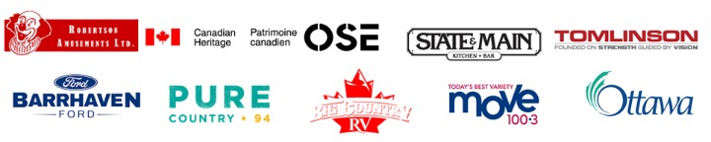

Sponsorship / Vendor Opportunities
Title Sponsor - Investment of $20,000 - MATTAMY HOMES
Media Sponsor – Investment of $15,000+ in radio / TV advertising -- IN KIND - BELL MEDIA
- Preferred logo position on advertising, promotional material, Website with link to your Website
- Logo included on large “thank you” board on site and on letterhead. Special mention included at ceremony.
Fireworks Sponsor – Investment of $15,000 – AVAILABLE OR $5,000.00 X 3 AVAILABLE
- Recognition as Fireworks sponsor on promotional material and company logo and link on Website
- Logo included on “thank you” board on site, special mention included at ceremony. Logo on letterhead
Main Stage Sponsor – Investment of $5,000 – BARRHAVEN STATE & MAIN
- Recognition as Main stage sponsor on promotional material and company logo and link on Website
- Logo included on “thank you” board on site, on main stage top and side banners
- Logo on large main stage line-up boards and special mention included at ceremony. Logo on letterhead
Comfort Station Sponsor – Investment of $5,000 – IN KIND - TOMLINSON GROUP
- Recognition as Comfort Station sponsor on promotional material and company logo and link on Website
- Logo included on “thank you” board on site.Special mention included at ceremony. Logo on Letterhead
Main Stage Entertainment Sponsor – Investment of $5,000 - WEST BARRHAVEN COMMUNITY ASSOCIATION
- Recognition as Main stage entertainment sponsor on promotional material and company logo on Website
- Logo included on large “thank you” board on site, on main stage side panels and main stage line-up boards
- Special mention included at ceremony.
Musicfest Day Sponsor – Investment of $3,000 – BIG COUNTRY RV
- Recognition as County Music Night sponsor on promotional material and company logo on Website
- Logo included on large “thank you” board on site. Special mention included at ceremony.
- Name and logo on large signs at event
Multicultural Day Sponsor – Investment of $4,000 – STATE AND MAIN
- Recognition as Multicultural Night sponsor on promotional material and company logo on Website
- Logo included on large “thank you” board on site. Special mention included at ceremony.
- Name and logo on large signs at event
Volunteer Sponsor – Investment of $3,000 – MCDONOUGH'S INDEPENDENT GROCER
- Recognition as Volunteer sponsor on promotional material and company logo on Website
- Logo included on large “thank you” board on site and logo on the back of all volunteer t-shirts
- Special mention included at ceremony.
Car Show Day Sponsor – Investment of $3,000 – AVAILABLE
- Recognition as Classic Car Show Day sponsor on promotional material and company logo on Website
- Name and logo on large sign at event
- Logo included on large “thank you” board on site. Special mention included at ceremony.
Advertising Sponsor – Investment of $3,000 – DAVID HILL
- Recognition as Advertising sponsor on promotional material and company logo on Website
- Logo included on large “thank you” board on site. Special mention included at ceremony.
Security sponsor – Investment of $3,000 – WILSON LO
- Recognition as Security sponsor on promotional material and company logo on Website
- Logo included on large “thank you” board on site. Special mention included at ceremony.
Seniors / Family Breakfast Meal Sponsor – Investment of $3,000 - BARRHAVEN LEGION
- Recognition as Breakfast Meal sponsor on promotional material and company logo on Website
- Name and logo on large banner on tent. Logo included on all breakfast tickets
- Opportunity for Legion to have members serve and/or enjoy a free breakfast
- Logo included on large “thank you” board on site and special mention included at ceremony.
Kidz Zone Title Sponsor – Investment of $3,000 – CAIVAN HOMES
- Recognition as Kids Zone sponsor on all promotional material and company logo on Website
- Logo included on large “thank you” board on site and on large gateway to Kidz Zone
- Large gateway banner at the entrance of the Kidz Zone and special mention included at ceremony.
Electrical Power Sponsor – Investment of $2,000 – BARRHAVEN FORD ELECTRIFICATION LEADERS
- Recognition as Electrical sponsor on all promotional material and company logo on Website
- Logo included on large “thank you” board on site and on large gateway to Kidz Zone
- Special mention included at ceremony.
Music Fest Stage and Entertainment Sponsor – Investment of $2,000 – WATERFORD GRAND RETIREMENT LIVING
- Recognition as Multi-Cultural Entertainment sponsor on promotional material, company logo on Website
- Name and logo on large banner on stage
- Logo included on large “thank you” board on site and special mention included at ceremony
Food Court Dining Tent Sponsor – Investment of $2,000 - MYERS GROUP
- Recognition as Food Court Dining Tent sponsor on promotional material and company logo on Website
- Name and logo on large banner on tent
- Logo included on large “thank you” board on site. Special mention included at ceremony.
Kidz Zone Stage Sponsor - Investment of $2,000.-- CANADIAN SPORTS MARTIAL ARTS ACADEMY
- Recognition as Kids Zone stage sponsor on promotional material and company logo on Website
- Name and logo on large banner on stage and Special mention included at ceremony.
- Logo included on large “thank you” board on site and stage named after sponsor with large banner
Kidz Zone Stage Entertainment Sponsor - Investment of $2,000 – BIG COUNTRY RV
- Recognition as Kids Zone Entertainment sponsor on promotional material and company logo on Website
- Name and logo on large banner on stage
- Logo included on large “thank you” board on site and special mention included at ceremony.
Absolute Comedy Dinner and Show Fundraiser Sponsors– Comedian Sponsorship $700.00 x 2 ALL CANADIAN ENTERTAINMENT, BARRHAVEN ROTARY CLUB
- Recognition as Absolute Comedy Dinner and Show sponsor on promotional material/company logo on Website
- Name and logo on large sign at Canada Day event. Logo on tickets and show poster, mention at show event
- Logo included on a large “thank you” board on site. Special mention included at ceremony.
Entry Gate Sponsor – Investment of $1,500 - or ($500 per gate) – IN KIND - ARX FENCING
- Recognition as Entry Gate Sponsor on 4’ x 4’ sign at Gates 1, 2 & 3 and company logo on Website
- Logo included on large “thank you” board on site and special mention included at ceremony.
Headliner Band Accomodation Sponsor – Investment of $1,000 - - AVAILABLE
- Recognition as Headliner Band Accom. sponsor on all promotional material and company logo on Website
- Logo included on large “thank you” board on site and special mention included at ceremony.
Senior / Family Breakfast Tent Sponsor – Investment of $1,000 - - WATERFORD GRAND RETIRE/LIVING
- Recognition as Family Breakfast Tent sponsor on all promotional material and company logo on Website
- Name and logo on large banner on tent
- Logo included on large “thank you” board on site and special mention included at ceremony.
Senior / Family Breakfast Entertainment Sponsor – Investment of $1,000 - AVAILABLE
- Recognition as Breakfast Entertainment sponsor on promotional material and company logo on Website
- Name and logo on large banner on tent
- Logo included on large “thank you” board on site and special mention included at ceremony
Security Lighting Sponsor – Investment of $1,000 - - JENNA AND COMPANY
- Recognition as Security Lighting sponsor on promotional material. company logo on Website
- Logo included on large “thank you” board on site and special mention included at ceremony.
Shuttle Bus Sponsor – Investment of $1,000 - - HEART & CROWN BARRHAVEN
- Recognition as Shuttle bus sponsor on promotional material and company logo on Website
- Logo included on large “thank you” board on site and posted at all pick up and drop off points
- Special mention included in media advisory and in thank you letters.

Multi-Cultural Stage Sponsor – Investment of $1,000 - - BRADLEY HISCOCK MCCRACKEN LAWYERS
- Recognition as Multi-Cultural stage sponsor on promotional material and company logo on Website
- Name and logo on large banner on stage
- Logo included on large “thank you” board on site and special mention included at ceremony.

Multi-Cultural Stage Entertainment Sponsor – Investment of $1,000 - - SOUTH NEPEAN MUSLIM COMMUNITY
- Recognition as Multi-Cultural Entertainment sponsor on promotional material, company logo on Website
- Name and logo on large banner on stage
- Logo included on large “thank you” board on site and special mention included at ceremony.

Kidz Zone Activities Sponsor - Investment of $1,000 - - BARRHAVEN OPTOMETRIC
- Recognition as Kids Zone Activities sponsor on promotional material and company logo on Website
- Logo included on large “thank you” board on site. Special mention included at ceremony.

Kidz Zone Craft Sponsor - Investment of $1,000 - - BOSTON PIZZA
- Recognition as Kids Zone Craft sponsor on promotional material and company logo on Website
- Logo included on large “thank you” board on site. Special mention included at ceremony.
Kidz Zone Prize Tent Sponsor - Investment of $1,000 - - COBS BREAD BAKERY
- Recognition as Kids Prize Tent sponsor on promotional material and company logo on Website
- Logo included on large “thank you” board on site and special mention included at ceremony.
Volunteer Meals Sponsor – Investment of $1,000 – - AVAILABLE
- Recognition as Volunteer meals sponsor on all promotional material and company logo on Website
- Logo included on large “thank you” board on site. Special mention included at ceremony.
Information Tent Sponsor – Investment of $1,000 - - BARRHAVEN PHARMASAVE
- Recognition as Information Tent sponsor on promotional material, tent banner, company logo on Website
- Logo included on large “thank you” board on site. Special mention included at ceremony.
First Aid Tent Sponsor – Investment of $1,000 - - EXHĀLŌ SPA
- Recognition as First Aid Tent sponsor on promotional material, tent banner, company logo on Website
- Logo included on large “thank you” board on site. Special mention included at ceremony.
Waste Management Sponsor - Investment of $1,000 - - DEAN RYANS – IN KIND
- Recognition as Waste Management sponsor on promotional material and company logo on Website
- Logo included on large “thank you” board on site. Special mention included at ceremony.
Green Room / Office Sponsor -Investment of $1,000 – BIG COUNTRY RV
- Recognition as Green Room sponsor on promotional material and company logo on Website
- Logo included on large “thank you” board on site. Special mention included at ceremony.
Bicycle lock-up Sponsor – Investment of $1,000 – MR. LUBE
- Recognition as bicycle lock-up sponsor on promotional material and company logo on Website
- Logo included on large “thank you” board on site. Special mention included at ceremony
Security Fence Sponsor - Investment of $500 X 3 or In-kind -STONEBRIDGE COMMUNITY ASSOCIATION
HALF MOON BAY COMMUNITY ASSOCIATION – ONE AVAILABLE
- Recognition as Security Fence sponsor on promotional material and company logo on Website
- Logo included on large “thank you” board on site
Main Stage Ceremony Sponsor – Investment of $500 - - SURGENOR BARRHAVEN
- Recognition as Main Stage Ceremony sponsor on promotional material and company logo on Website
- Logo included on large “thank you” board on site
Bicycle lock-up Sponsor – Investment of $1,000 – MR. LUBE
- Recognition as bicycle lock-up sponsor on promotional material and company logo on Website
- Logo included on large “thank you” board on site
Gold - Sponsors – Investment of $700 - $1,000 (donations of $700 are eligible for a vendor space) AVAILABLE
- Logo included on large “thank you” board on site
- Logo on Mattamy Homes Canada Day in Barrhaven Website
Silver – Sponsors - Investment of $500 - $699 (add a vendor space for $200.00) AVAILABLE
- Logo included on large “thank you” board on site
- Logo on Mattamy Homes Canada Day in Barrhaven Website.
Bronze – Sponsors - Investment of $300 - $499 (add a vendor space for $300.00) AVAILABLE
- Logo included on large “thank you” board on site
- Logo on Mattamy Homes Canada Day in Barrhaven Website.
Non-food Vendor-Cost is $300.00 + $100.00 FOR HYDRO. Submit plan for approval in a letter or an email.
Vendor Village Members $100.00 + 100.00 FOR HYDRO. Please see web page for more information.
Food Vendor-Cost is $800.00 + $200.00 FOR HYDRO Submit your menu, set up plan, copy of insurance policy and a picture of your electrical plug where applicable.

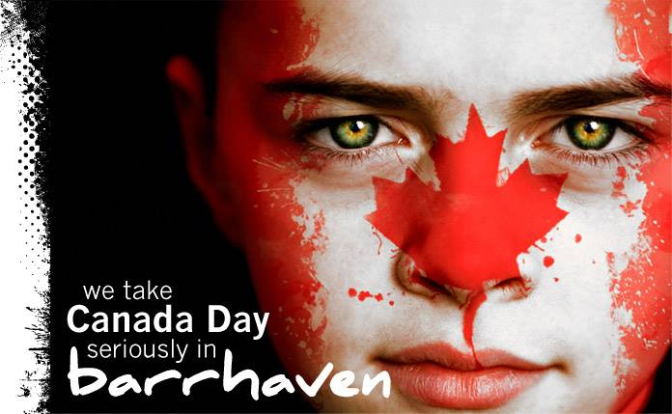

Mattamy Homes Canada Day in Barrhaven
July 1st, 2024, 8 a.m. to 11 p.m.
Sponsorship/Vendor Registration Form

Sponsor/Vendor name: ____________________________________________

Sponsor/Vendor address: _____________________________________________

Contact person name/title: ___________________________________________

Phone number(s): ___________ E-mail address: ____________________

Sponsor/Vendor Website:_____________________________________________
Major sponsors of $5,000+ will have their logo on every page on our website and letterhead
SPONSORSHIP/VENDOR OPPORTUNITY PACKAGE | AMOUNT
(Please fill in requested sponsorship opportunity package here) | $
Gold – Sponsors $700 - $1,000 | $
Silver – Sponsors $500 - $700 | $
Bronze – Sponsors $300 - $500 | $
Food vendor space request $800 | $
Non-Food vendor space request $300 | $
VENDORS: Do you need Hydro yes/no Water yes/no
Hydro for food or non-food vendors $200 | $
TOTAL – Cheque payable to ‘Canada Day Barrhaven Inc.’ | $
In addition to above, all sponsors/vendors taking a minimum $500.00 sponsorship or vendor fee plus a one-time donation of $125.00 gets you a 4’x4’ logo sign posted at event in perpetuity as long as you continue with a minimum $500.00 sponsorship/vendor fee in the following years. Sponsors of at least $1,000.00 get the above sign and a booth included with sponsorship
Please send us a copy of your logo and link to your website.
For more information on these or other sponsorship opportunities not mentioned please contact Darrell Bartraw 613-298-9119(c), email form to ucanemaildbart@gmail.com
Mailing address: 18 Pepperrall Cres Ottawa (Barrhaven) Ontario K2J 3V8.
*NEW Now payments can be send by e-transfer to treasurer@canadadaybarrhaven.ca
www.canadadaybarrhaven.ca

